‘I’ve been there for 43 years.’ Ann Arbor airport business owner upset with city
- Published: Nov. 22, 2022, 12:39 p.m.
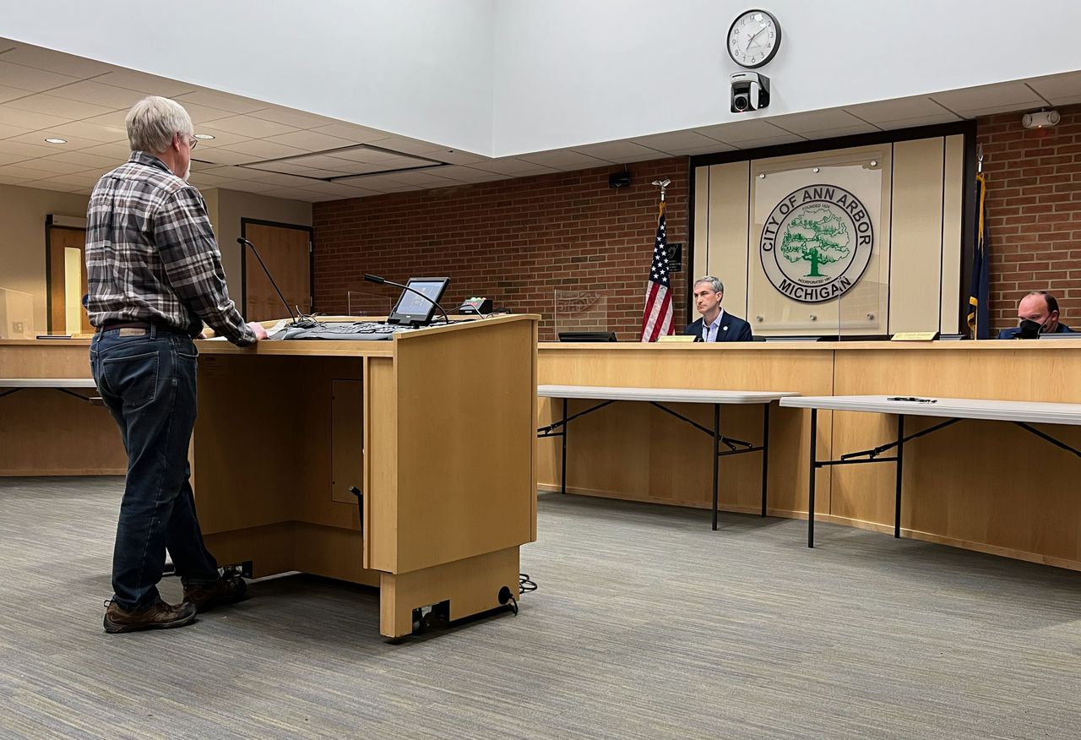
Mark Roisen, longtime owner of the Aviation Center at the Ann Arbor Municipal Airport, speaks out at the City Council meeting Nov. 21, 2022.Ryan Stanton | The Ann Arbor News

NEW!
By
- Ryan Stanton | ryanstanton@mlive.com
ANN ARBOR, MI — Ann Arbor officials are moving in a new direction with a corporate hangar space at the city’s airport and that doesn’t fly with Mark Roisen.
Roisen, longtime owner of the Aviation Center at the Ann Arbor Municipal Airport, spoke out Monday night, Nov. 21, before City Council voted unanimously to lease his space at 719 Airport Drive to a new company for the next 20 to 30 years: Great Lakes Air Repair, doing business as Beacon Aviation.
“I’ve been there for 43 years, performing duties to accommodate the maintenance, fueling, aircraft rental, instruction and so on,” Roisen said, telling council he has major concerns about the new lease with Beacon Aviation.
Roisen said he’s disappointed he had to forfeit the building to the city when his lease ran out, which he said was a value of about $750,000, and he could not get another lease.
He’s trying to leave his business and retire, but he wanted to leave it to someone who could continue it with all of the same services and employees, he said.
“And I’m afraid that with this other lease, that will not happen,” he told council.
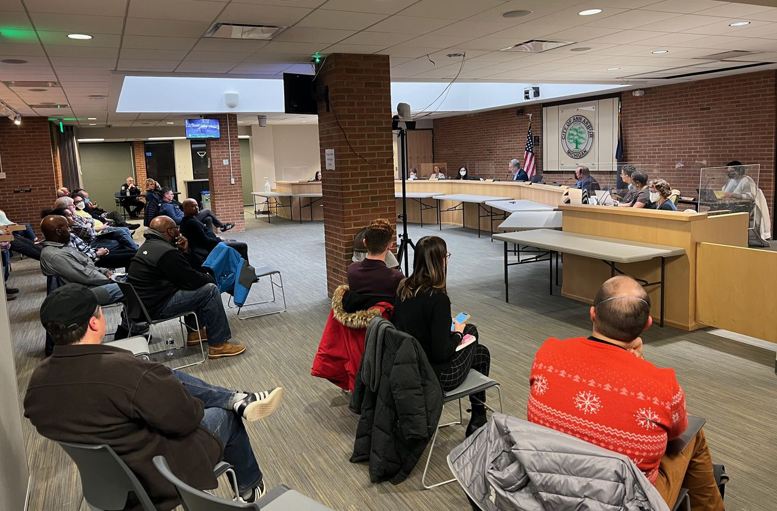
The first meeting of Ann Arbor's new City Council on Nov. 21, 2022.Ryan Stanton | The Ann Arbor News
Roisen called for postponement, while council also heard from one of Roisen’s longtime customers, a pilot and flight instructor who urged council to turn down the new lease.
But after a few minutes of discussion, council voted 11-0 to approve it, with city officials noting Beacon Aviation plans to make nearly $200,000 worth of required improvements to the property based on a city building condition assessment.
Beacon Aviation also has strong experience as an airport fixed-base operator, said Erica Briggs, D-5th Ward, council liaison to the city’s airport advisory committee.
“They would be offering the current services, as well as new services is my understanding,” she said.
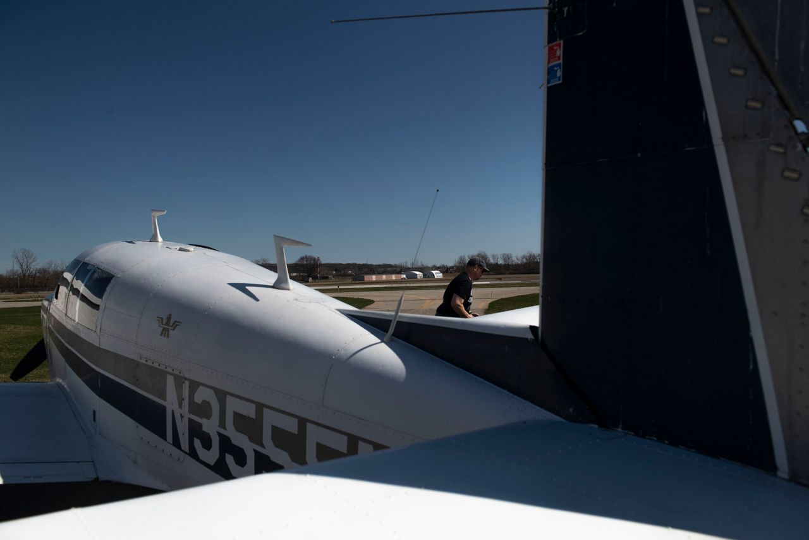
Hans Masing prepares to fly across country to deliver PPE to other hospitals during the COVID-19 pandemic on April, 3, 2020, at the Ann Arbor Municipal Airport. Nicole Hester/Mlive.com
Matt Kulhanek, the city’s fleet and facilities manager, told council Beacon Aviation is owned by Dale Foerschler and Brian Herron, and they will be increasing the services available to the local aviation community by adding avionics, aircraft painting and upholstery repairs in addition to traditional FBO services.
Foerschler also operates a successful FBO (Great Lakes Air Ventures) in Mason, and Herron is a longtime airport tenant, local businessman and owner of the Herron Aviation Group, which handles aircraft sales, Kulhanek said.
In his remarks to council, Roisen expressed concerns about the plans for aircraft painting, calling it a dirty process and suggesting it’s a bad idea given the city has wells to draw drinking water from the aquifer beneath the airport property. Roisen also expressed fears using the building for painting could push other services to a different location, possibly out to Mason.
City officials responded by saying the paint shop operations would be in Mason. And while Beacon Aviation hasn’t committed to retaining existing Aviation Center employees, it is interested in interviewing them, officials said.
The new lease runs for 20 years, with an option to extend it another 10 years, for a total of 30 years.
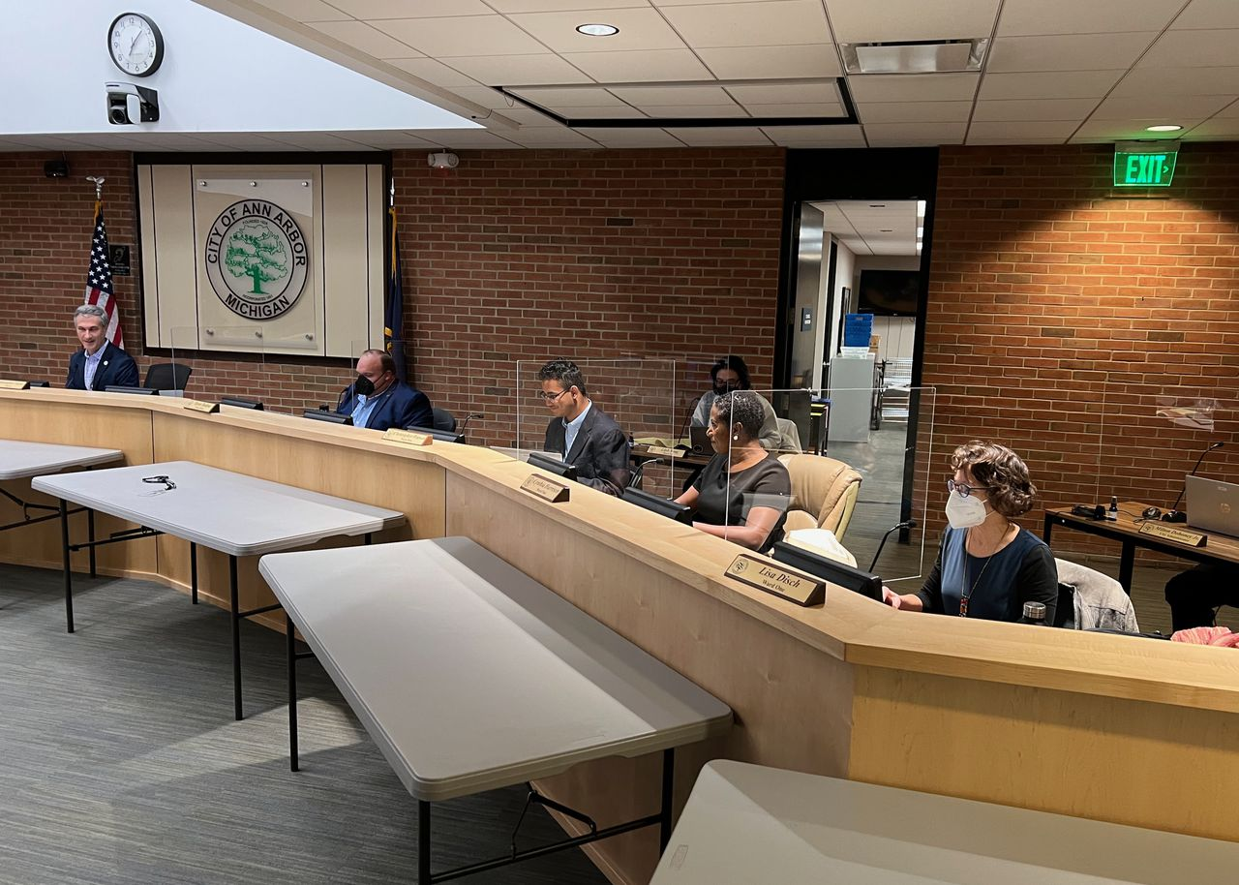
The first meeting of Ann Arbor's new City Council on Nov. 21, 2022.Ryan Stanton | The Ann Arbor News
The corporate hangar at 719 Airport Drive has been a privately owned hangar on a longterm land lease with the city since the 1960s, owned by the Aviation Center the last four decades. The company’s lease expired in 2018 and it has continued on a month-to-month basis since then, Kulhanek said.
“Per the land lease, the building ownership reverts to the city at the end of the lease agreement,” he wrote in a memo.
The new lease rate is the same, so the change to a new operator is revenue-neutral, Kulhanek said.
The lease is structured so the city will continue ownership of the building, while Beacon Aviation is responsible for building and ramp improvements, insurance, utilities, maintenance work such as mowing and snowplowing, and any taxes.
Unlike other airport-owned buildings, the city has no ongoing financial responsibilities for the hangar, aircraft ramp or grounds, and the continued lease has a positive impact on the airport’s budget, Kulhanek said.
“We went through literally a multi-year, multi-RFP process to find what we feel is the best benefit for the airport and the users of the airport,” he said.

City Clerk Jackie Beaudry leads Ann Arbor's new City Council members and Mayor Christopher Taylor in a swearing-in ceremony at the first meeting of the new council Nov. 21, 2022. From left, the new council members are Jenn Cornell, Dharma Akmon, Ayesha Ghazi Edwin, Chris Watson and Cynthia Harrison.Ryan Stanton | The Ann Arbor News
A city staff memo more fully explained the process and responded to issues raised. It stated Aaron Enzer of ACE Aircraft LLC expressed a desire to purchase the building, requested a renewal of the Aviation Center lease and also responded to the city’s request for proposals, but the city ultimately decided to go with Beacon Aviation.
“I can say that we did a thorough due-diligence process on this proposer,” Kulhanek said, expressing confidence Beacon Aviation will be a nice asset for the community.
The timeline in the proposal indicates renovations could be done in 90 days and full FBO service could come online in six months, with some operations beginning immediately.
Expressing her support and comfort going forward with the new operation, Council Member Jen Eyer, D-4th Ward, said she was reassured by the involvement of Herron, saying he has a stellar business record in the community.

